// Add services to the container.

builder.Services.AddControllers();

Right After AddController

//to serve static files like images

builder.Services.AddHttpContextAccessor();

Program.cs file

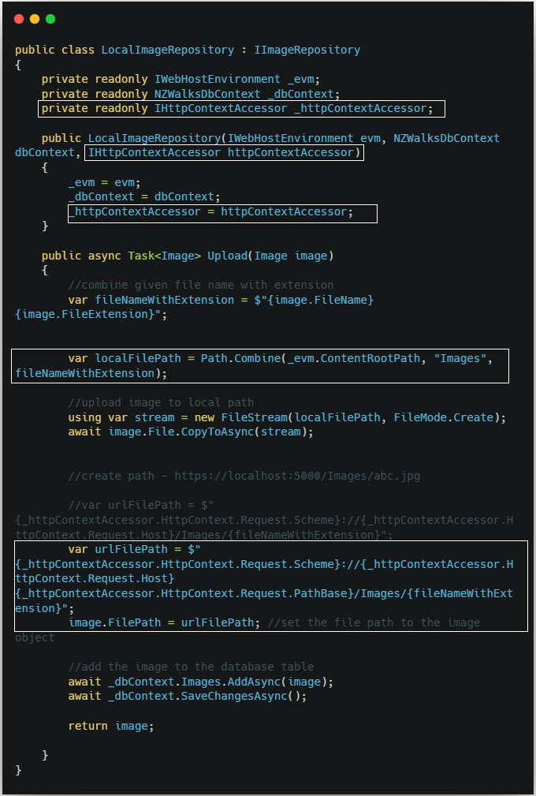

🔸 Line:

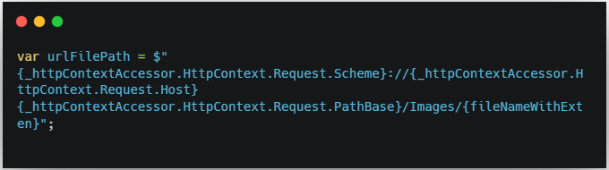

**🔸 Purpose:**

Ye line ek **URL** generate karti hai jo uploaded image ka **public path** hota hai — jaise browser me open hone wala image ka link.

**🔸 Breakdown (Part-by-Part):**

**1. _httpContextAccessor.HttpContext.Request.Scheme**

🔹 Ye http ya https batata hai.  
🔸 Example: "https"

**2. _httpContextAccessor.HttpContext.Request.Host**

🔹 Isme domain name aata hai (localhost ya live domain)  
🔸 Example: "localhost:5001"  
🔸 Real-world: "www.mysite.com"

**3. _httpContextAccessor.HttpContext.Request.PathBase**

🔹 Ye application ka base path batata hai agar aap app kisi subfolder me host kar rahe hain.  
🔸 Mostly empty hota hai agar directly host kiya gaya ho.

**4. /Images/{fileNameWithExten}**

🔹 Ye static folder ka path hai jahan image save ki gayi hai  
🔸 Example: /Images/student1.jpg

**🔸 Full Example:**

Agar:

* Scheme: https
* Host: localhost:5001
* PathBase: (blank)
* File Name: student1.jpg

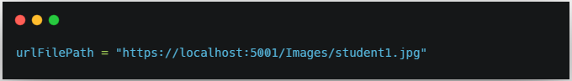

**_httpContextAccessor.HttpContext.Request.PathBase**

* **Request.PathBase** sirf tab kaam aata hai jab aapki app kisi sub‑folder **(e.g. https://site.com/myapp/)** me host ho.
* Agar aapki app **root** **(https://site.com/)** pe hai, to PathBase hamesha blank return karega, yani "".

**Real‑world example:**

* Aapki image folder project root me hai aur app bhi root pe chal rahi hai

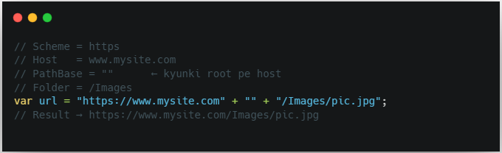

Agar future me app ko https://www.mysite.com/schoolapp/ me shift kar diya, to PathBase automatically "/schoolapp" dega aur URL sahi rahega:

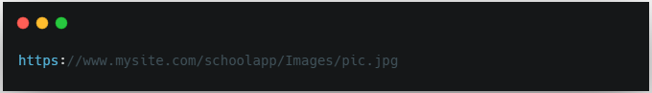

**Conclusion:**

* **Jarurat** nahi hai agar aap hamesha root pe hi host karenge—us case me PathBase blank hi rahega.
* **Phir bhi include karna best practice** hai, taaki future me sub‑folder shift ke time URL logic automatically handle ho jaaye.

Note:



**automatically** "/schoolapp" return karega — aapko manually set karne ki zarurat nahi hoti.